Euclidean Geometry Terms

Definition
# Source: AI Source: Provided by: [Data Path: Persons Table -> ID Column: 1, Name_En Column: Motasem Essam] -> From: [ChatGPT] on [7/25/2026]
In Euclidean Geometry, terms are classified into undefined terms and defined terms according to whether their meanings are taken as basic concepts or are established using previously known concepts.

Undefined Terms
# Source: AI Source: Provided by: [Data Path: Persons Table -> ID Column: 1, Name_En Column: Motasem Essam] -> From: [ChatGPT] on [7/25/2026]
Undefined terms are the fundamental concepts whose meanings are accepted without formal definitions within a particular axiomatic system.
The three traditional undefined terms of Euclidean Geometry are:
- Point
- Line
- Plane
They are described intuitively rather than completely defined.
For example:
- A point represents an exact location but has no dimension.
- A line represents a straight path extending infinitely in both directions.
- A plane represents a flat surface extending infinitely in two dimensions.
These descriptions help us understand the concepts, but they are not formal definitions in the axiomatic sense.

Defined Terms
# Source: AI Source: Provided by: [Data Path: Persons Table -> ID Column: 1, Name_En Column: Motasem Essam] -> From: [ChatGPT] on [7/25/2026]
Defined terms are geometric concepts whose meanings are established using undefined terms, previously defined terms, and accepted relationships.
Examples include:
- Segment
- Ray
- Angle
- Parallel lines
- Perpendicular lines
- Triangle
- Quadrilateral
- Circle
- Polygon
For example:
A line segment is the part of a line between two endpoints.
The concept of a segment depends on the previously accepted concept of a line and the concept of points.

Purpose
The distinction between undefined and defined terms provides the foundation of an axiomatic system.
It allows geometry to be constructed in a logical order:
Undefined Terms → Definitions → Axioms/Postulates → Theorems → Proofs
Without fundamental starting concepts, every definition would require another definition, creating an infinite chain.

Undefined Terms

1. Point
# Source: AI Source: Provided by: [Data Path: Persons Table -> ID Column: 1, Name_En Column: Motasem Essam] -> From: [ChatGPT] on [7/25/2026]
A point represents a precise location in space.
A point has:
- No length
- No width
- No thickness
It is commonly represented by a capital letter:
$$A$$
or
$$B$$

2. Line
# Source: AI Source: Provided by: [Data Path: Persons Table -> ID Column: 1, Name_En Column: Motasem Essam] -> From: [ChatGPT] on [7/25/2026]
A line is a straight geometric object extending infinitely in two opposite directions.
A line can be represented using two points:
$$\overset{↔}{AB}$$
where $A$and $B$are points on the line.

3. Plane
# Source: AI Source: Provided by: [Data Path: Persons Table -> ID Column: 1, Name_En Column: Motasem Essam] -> From: [ChatGPT] on [7/25/2026]
A plane is a flat two-dimensional geometric surface extending infinitely in all directions within that surface.
A plane can be represented using three non-collinear points:
$$\text{Plane }ABC$$
where $A$, $B$, and $C$do not lie on the same line.
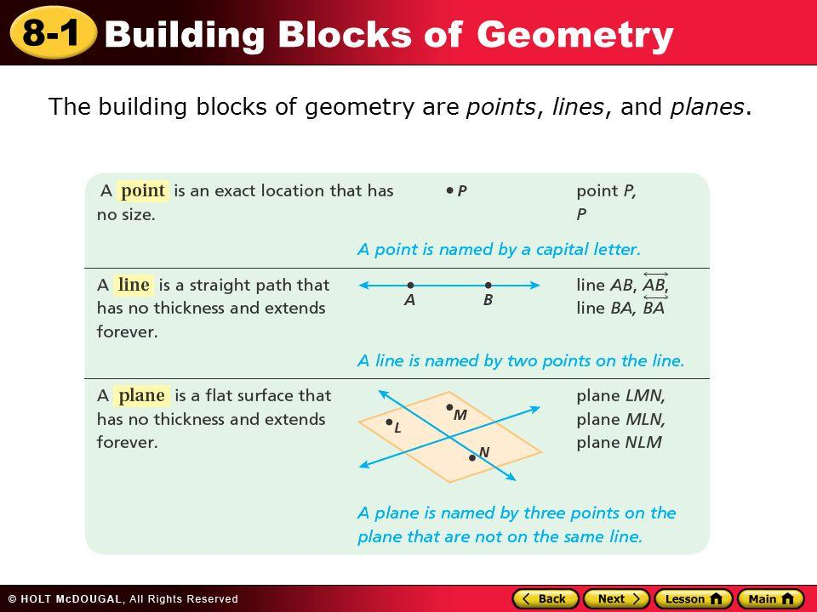
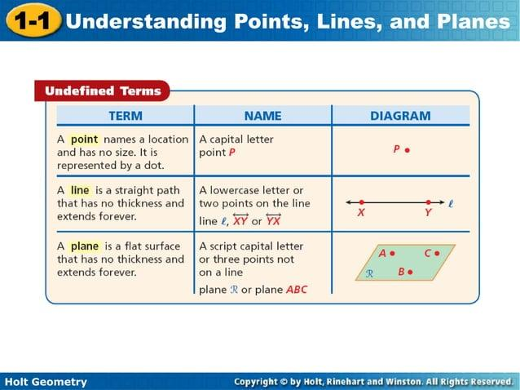
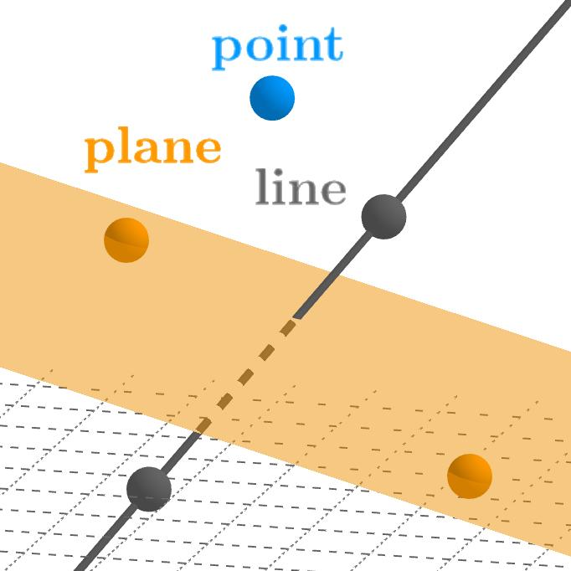
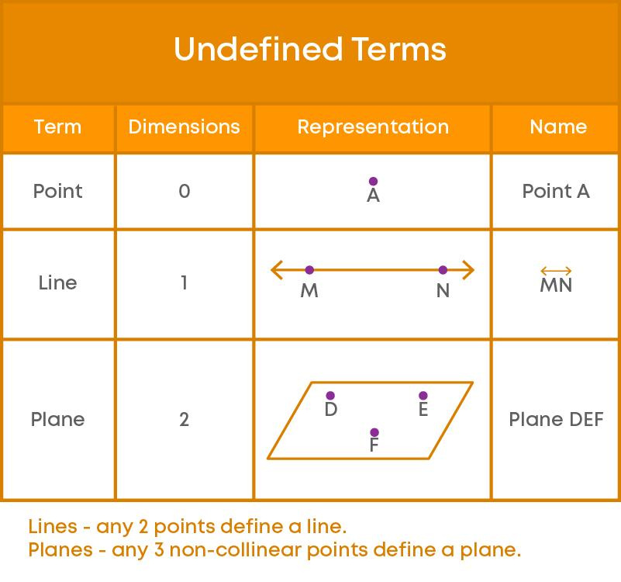

Defined Terms
# Source: AI Source: Provided by: [Data Path: Persons Table -> ID Column: 1, Name_En Column: Motasem Essam] -> From: [ChatGPT] on [7/25/2026]
Defined terms are constructed from the fundamental concepts.
Line Segment
A line segment is the portion of a line between two endpoints.
$$\overset{‾}{AB}$$

Ray
# Source: AI Source: Provided by: [Data Path: Persons Table -> ID Column: 1, Name_En Column: Motasem Essam] -> From: [ChatGPT] on [7/25/2026]
A ray is a part of a line that begins at one endpoint and extends infinitely in one direction.
$$\vec{AB}$$
Here, $A$is the endpoint and the ray extends through $B$.

Angle
# Source: AI Source: Provided by: [Data Path: Persons Table -> ID Column: 1, Name_En Column: Motasem Essam] -> From: [ChatGPT] on [7/25/2026]
An angle is formed by two rays that share a common endpoint.
$$∠ABC$$
The common endpoint $B$is the vertex.

Parallel Lines
# Source: AI Source: Provided by: [Data Path: Persons Table -> ID Column: 1, Name_En Column: Motasem Essam] -> From: [ChatGPT] on [7/25/2026]
Two lines are parallel if they lie in the same plane and do not intersect.
$$l_{1}∥l_{2}$$

Perpendicular Lines
# Source: AI Source: Provided by: [Data Path: Persons Table -> ID Column: 1, Name_En Column: Motasem Essam] -> From: [ChatGPT] on [7/25/2026]
Two lines are perpendicular if they intersect to form right angles.
$$l_{1}⊥l_{2}$$

Triangle
# Source: AI Source: Provided by: [Data Path: Persons Table -> ID Column: 1, Name_En Column: Motasem Essam] -> From: [ChatGPT] on [7/25/2026]
A triangle is a polygon consisting of three line segments, three vertices, and three interior angles.
$$△ABC$$

Circle
# Source: AI Source: Provided by: [Data Path: Persons Table -> ID Column: 1, Name_En Column: Motasem Essam] -> From: [ChatGPT] on [7/25/2026]
A circle is the set of all points in a plane that are a fixed distance from a fixed point called the center.
$$r=\text{constant}$$
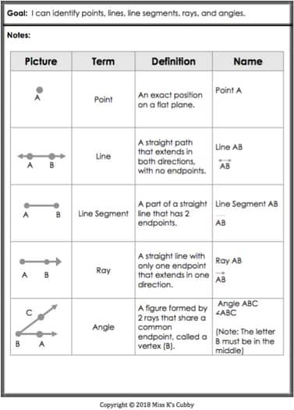
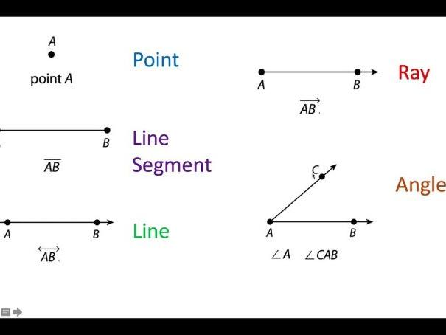
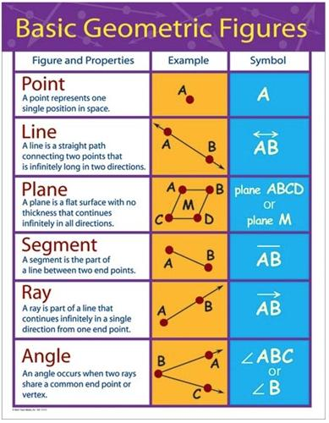
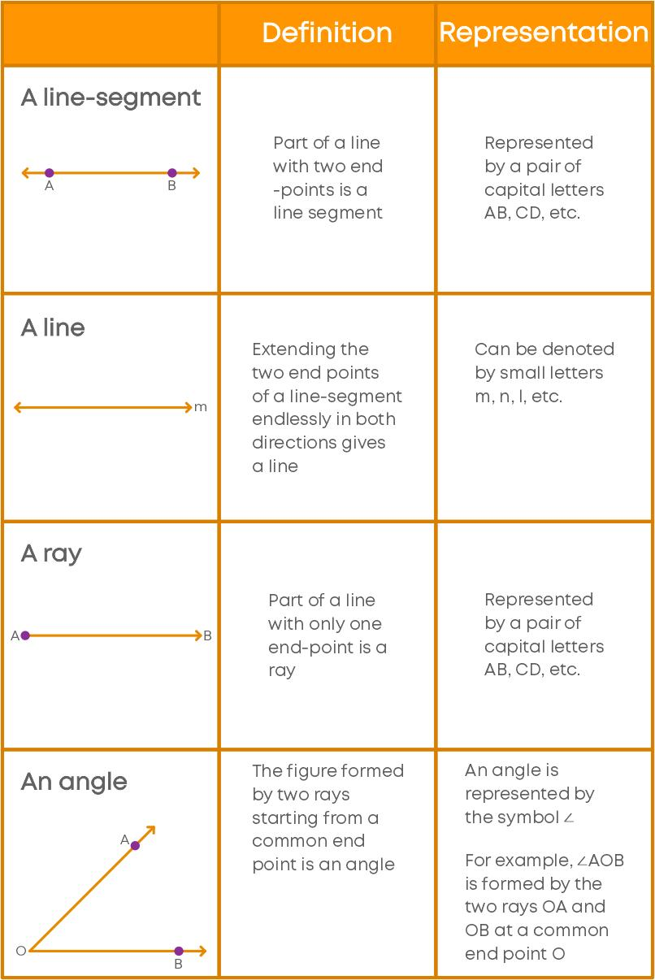

Relationship Between Undefined and Defined Terms
# Source: AI Source: Provided by: [Data Path: Persons Table -> ID Column: 1, Name_En Column: Motasem Essam] -> From: [ChatGPT] on [7/25/2026]
Defined terms depend on the fundamental undefined terms.
For example:
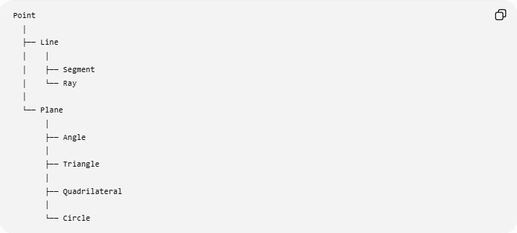
Point
│
├── Line
│ │
│ ├── Segment
│ └── Ray
│
└── Plane
│
├── Angle
│
├── Triangle
│
├── Quadrilateral
│
└── Circle
A more general logical structure is:
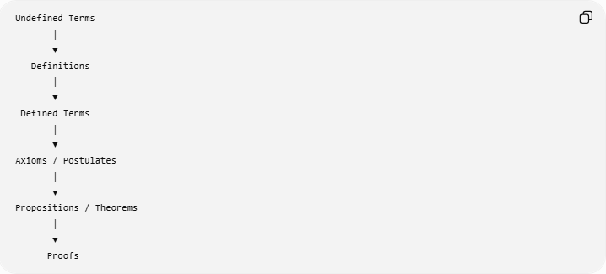
Undefined Terms
│
▼
Definitions
│
▼
Defined Terms
│
▼
Axioms / Postulates
│
▼
Propositions / Theorems
│
▼
Proofs

Examples

Example 1: Segment
# Source: AI Source: Provided by: [Data Path: Persons Table -> ID Column: 1, Name_En Column: Motasem Essam] -> From: [ChatGPT] on [7/25/2026]
Start with two points $A$and $B$.
The portion of the line connecting $A$and $B$is the segment:
$$\overset{‾}{AB}$$
Therefore, the segment is a defined term based on points and a line.

Example 2: Angle
# Source: AI Source: Provided by: [Data Path: Persons Table -> ID Column: 1, Name_En Column: Motasem Essam] -> From: [ChatGPT] on [7/25/2026]
Two rays share endpoint $B$:
$$\vec{BA}$$
and
$$\vec{BC}$$
Together they form:
$$∠ABC$$
Therefore, an angle is a defined term.

Example 3: Triangle
# Source: AI Source: Provided by: [Data Path: Persons Table -> ID Column: 1, Name_En Column: Motasem Essam] -> From: [ChatGPT] on [7/25/2026]
Three non-collinear points $A$, $B$, and $C$are connected by segments:
$$\overset{‾}{AB}, \overset{‾}{BC}, \overset{‾}{CA}$$
The resulting figure is:
$$△ABC$$
Thus, a triangle is a defined geometric term.

Undefined Terms vs Defined Terms
# Source: AI Source: Provided by: [Data Path: Persons Table -> ID Column: 1, Name_En Column: Motasem Essam] -> From: [ChatGPT] on [7/25/2026]
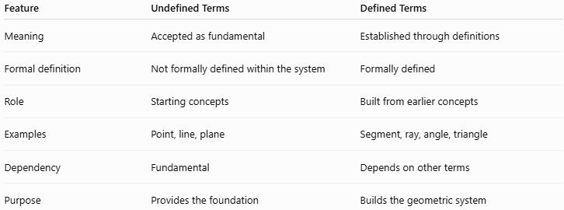
Feature | Undefined Terms | Defined Terms
Meaning | Accepted as fundamental | Established through definitions
Formal definition | Not formally defined within the system | Formally defined
Role | Starting concepts | Built from earlier concepts
Examples | Point, line, plane | Segment, ray, angle, triangle
Dependency | Fundamental | Depends on other terms
Purpose | Provides the foundation | Builds the geometric system

Important Note
# Source: AI Source: Provided by: [Data Path: Persons Table -> ID Column: 1, Name_En Column: Motasem Essam] -> From: [ChatGPT] on [7/25/2026]
The classification of a term as undefined depends on the chosen axiomatic system.
In traditional elementary Euclidean geometry, the standard undefined terms are:
$$\boxed{\text{Point, Line, Plane}}$$
However, modern axiomatic treatments can use different primitive concepts and relations. Therefore, "undefined" does not mean meaningless. It means that the term is taken as a primitive starting concept rather than being defined from simpler terms within that particular system.

Relationship with Euclidean Geometry
# Source: AI Source: Provided by: [Data Path: Persons Table -> ID Column: 1, Name_En Column: Motasem Essam] -> From: [ChatGPT] on [7/25/2026]
Undefined Terms and Defined Terms belong directly to the foundations of Euclidean Geometry.
A suitable knowledge-base hierarchy is:
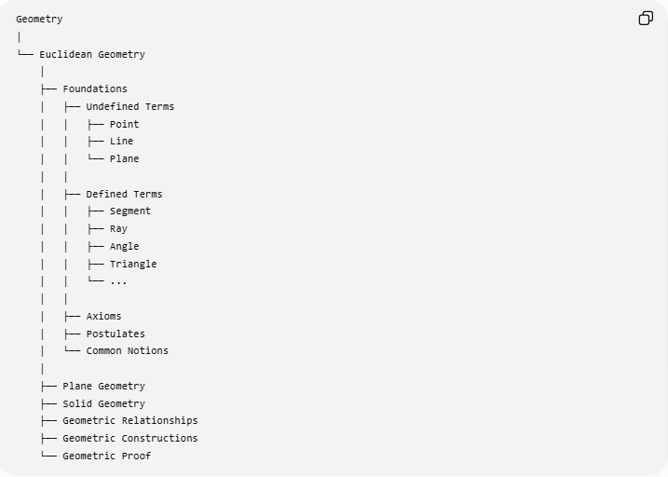
Geometry
│
└── Euclidean Geometry
│
├── Foundations
│ ├── Undefined Terms
│ │ ├── Point
│ │ ├── Line
│ │ └── Plane
│ │
│ ├── Defined Terms
│ │ ├── Segment
│ │ ├── Ray
│ │ ├── Angle
│ │ ├── Triangle
│ │ └── ...
│ │
│ ├── Axioms
│ ├── Postulates
│ └── Common Notions
│
├── Plane Geometry
├── Solid Geometry
├── Geometric Relationships
├── Geometric Constructions
└── Geometric Proof

Key Points
# Source: AI Source: Provided by: [Data Path: Persons Table -> ID Column: 1, Name_En Column: Motasem Essam] -> From: [ChatGPT] on [7/25/2026]
- Undefined terms are the primitive starting concepts of an axiomatic geometry.
- The traditional Euclidean undefined terms are point, line, and plane.
- Defined terms receive their meanings from previously established concepts.
- Examples of defined terms include segment, ray, angle, triangle, quadrilateral, and circle.
- Definitions create a logical connection between fundamental concepts and more complex geometric objects.
- Undefined and defined terms form part of the foundations of Euclidean Geometry.
- The classification can vary depending on the chosen axiomatic system.

Conclusion
# Source: AI Source: Provided by: [Data Path: Persons Table -> ID Column: 1, Name_En Column: Motasem Essam] -> From: [ChatGPT] on [7/25/2026]
Undefined Terms and Defined Terms establish the vocabulary and logical foundation of Euclidean Geometry. Undefined terms such as point, line, and plane serve as primitive starting concepts, while defined terms such as segment, ray, angle, triangle, and circle are constructed from those fundamental concepts. Together, they provide the basis for building definitions, axioms, postulates, theorems, and mathematical proofs.

